
Year 10 General

Mini Test 1
Index Laws and Algebraic Fractions

Score: /28
Name: ____________________________ Total Time: 35 minutes

Show working and answers on this sheet. Show working in sufficient detail to support your answers. Incorrect answers without supporting reasoning may be allocated zero marks. Calculators may be used. 1 side A4 notes (handwritten) allowed.

- Simplify the following expressions (leave your answers in index form) (10 marks)

  - $15m^{7}÷3m^{2}$

  - ${\left(2x^{6}y\right)}^{4}$

  - $2a^{3}×3a^{9}$

  - 2j3k2 × 4j−4k−3

  - $\frac{4x^{2}y×{\left(3xy^{4}\right)}^{2}}{2x^{4}y^{3}×3y^{8}}$

- Simplify the following expression (14 Marks)

  - $\frac{5x}{3}+\frac{8x}{3}$

  - $\frac{{5x}^{3}}{6}- \frac{{3x}^{3}}{6}$

  - $\frac{2x}{5}- \frac{x}{3}$

  - $\frac{y}{2}-\frac{z}{3}$

  - $\frac{k}{8}×\frac{4k}{3}$

  - $\frac{x+3}{2}+\frac{2x+1}{5}$

  - $\frac{2k+1}{2}÷\frac{k+7}{8}$

- Find the perimeter and area of the following shape (4 marks)

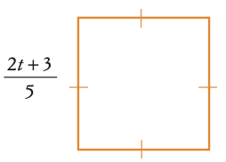

End of Test

